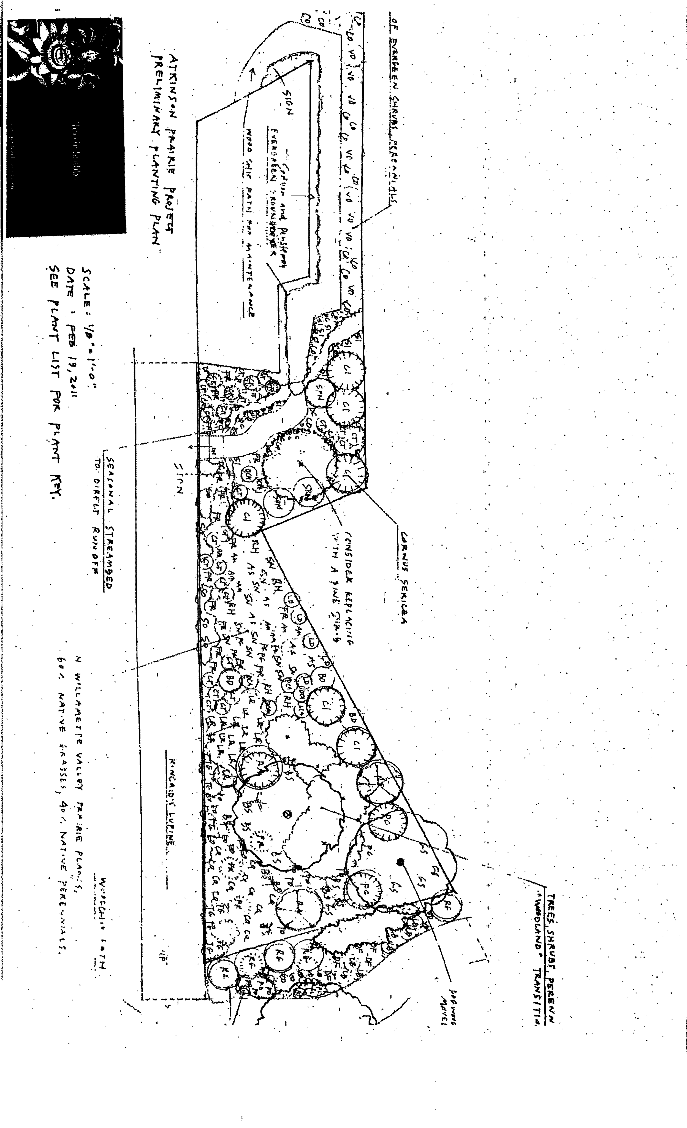
FOR THE ATKINSON ELEMENTARY SCHOOL COMMUNITY:
What’s happening near the Outdoor Classroom?
We are adding a new, unique garden area to the existing Outdoor Learning Garden (OLG): a prairie. We are also expanding the size and plant diversity within our pollinator and butterfly garden.
Current landscape design for the new Atkinson Elementary OLG prairie and pollinator garden
Who’s doing this, and why?
The Atkinson Elementary School Outdoor Learning Garden Committee, with help from Landscape Designer Terrie Stubbs, who designed the new garden areas, and the U.S. Fish and Wildlife Service, which is providing funding and volunteer time for the project.
We are adding a prairie garden because it represents a habitat that is native to the northern Willamette Valley. Prairie ecosystems are very diverse in terms of the number of plant and species that occupy them, and very rare (less than 10% of original Willamette prairie habitat now exists). At Atkinson Elementary, we celebrate diversity and uniqueness within our community, so adding to our outdoor classrooms network a habitat that is also unique and diverse fits our school’s philosophy.
How will this benefit our kids and their education?
Right now we (the OLG) are working to involve as many Atkinson students as possible in helping put the new plants into the garden. While they do this we will be discussing what a prairie habitat is, why species live there, and why prairies are important.
After planting the prairie garden and pollinator/butterfly garden the OLG will work on developing curriculum on prairie ecosystems and prairie species that will be shared with the teachers and OLG class representatives. This will complement existing science units each grade studies, ranging from pollinators in Kindergarten to native plants in Third Grade to Northwest Ecosystems in Fifth Grade. The prairie and expanded pollinator garden will provide even more opportunities for your child to learn about the natural world right on the Atkinson Elementary school campus.
What is a ‘prairie’ habitat, or ecosystem?
Prairies are among the rarest of North American ecosystems, and much of the original prairie across the United States--including the Willamette Valley--has been lost when land was converted to agricultural use and development. Prairie habitats are dominated by grasses and perennial plants that are adapted to shallow, dry soils and sunny, exposed conditions. Trees and shrubs grow in clumps or individually, depending on the level of moisture in the prairie or soil depth. Historically Native Americans regularly burned prairies to increase growth of food plants and to improve hunting. There are four major ecosystem types in the Willamette Valley: prairies, oak savannahs, wetlands, and coniferous forests.(Source: Gardening for Wildlife)
What is special about the Atkinson prairie garden?
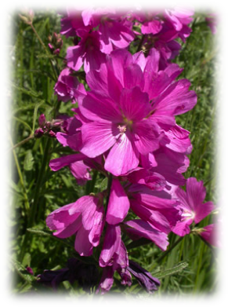
There are several prairie demonstration sites throughout the Willamette Valley, but ours is the only Portland Public School project that currently has a plant species that is listed as Threatened (likely to become endangered in the forseeable future) under the federal Endangered Species Act! The listed plant we have is called Nelson’s Checkermallow (Sidalcea nelsoniana): it is a perennial herb in the mallow family that has tall, lavender to deep pink flowers. The flowers are borne in clusters that are usually spike‐like, elongate, and somewhat open, and flowering from mid‐May into September. It is native to the Willamette Valley, and grows in meadows in wet areas, and along streams. (Source and photo credit: U.S. Fish and Wildlife Service)

The Willamette Valley is also home to the endangered Fender's blue butterfly; two endangered plants: Bradshaw's lomatium and Willamette daisy; Kincaid's lupine (the host plant for Fender's Blue butterfly), which is also threatened, one candidate for ESA listing: Taylor's checkerspot butterfly, a candidate for ESA listing, and one plant, peacock larkspur, which is listed as endangered by the state of Oregon. Depending on the success we have in maintaining Nelson’s Checkermallow in our prairie garden, we may consider the possibility of adding additional rare species in the future. Doing so will require getting a permit from the Oregon Department of Agriculture and U.S. Fish and Wildlife Service, as we did in order to host Nelson’s Checkermallow.
What is the project’s goal?
We want to educate children and adults within the Atkinson Elementary and Southeast Portland community about the function and value of prairie ecosystems. We also want to show how native plants and pollinators are important. Ecosystems are like human communities: they function better when they are diverse. We also want to use the project as a demonstration garden to inform and inspire others about how to attract pollinators, plant native plants, and connect with nature.
Who paid for this?
We are using nearly $700 that was raised when the OLG sold Chinook Books last fall, so if you bought a Chinook Book from the OLG, YOU helped make this garden happen!
In addition, last year the Atkinson OLG got a $550 funding award from the U.S. Fish and Wildlife Service, a federal conservation agency that protects migratory birds, native fish, Endangered Species Act-listed plants and animals, and owns National Wildlife Refuges and National Fish Hatcheries. The money has been used to buy native plants and items to attract pollinators.
Where is the prairie habitat going to be?
The prairie garden is just south of the Outdoor Classroom and west of the school’s playground. You’ll see it when either entering or exiting the school’s south entrance to/from Clinton Park. In fact, we are improving and expanding the Atkinson OLG pollinator garden that’s actually in Clinton Park with support from Portland Parks and Recreation.
What happened to the rhododendrons and the other plants that used to be there?
We moved the rhododendrons, a flowering dogwood, six Western Azaleas, and three Coyote bushes to the northwest corner of the school campus (the side near Franklin High’s baseball field and Dairy Queen). We did this to make room for the prairie plant species, and to give the plants we moved better growing conditions, since they were getting very hot and dried out in the summer.
What plants are being planted?
[INSERT A LIST OF PLANTS FROM THE MASTER PLANT LIST
Where did the plants come from?
We ordered our plants from…
How do I learn more about the prairie/pollinator garden project?
You can contact Atkinson parents Sean Connolly (503-460-0999; sean_connolly@comcast.net) or Patty Jordens (503-788-2563; pjordens@hevanetcom), for more information. To learn more about Willamette Valley prairies and the rare plants and animals in them, you can visit the following websites:
- http://people.oregonstate.edu/~wilsomar/Index.htm
- http://www.flickr.com/photos/usfwspacific/sets/72157626148488795/
- http://www.fws.gov/oregonfwo/
- http://www.fws.gov/willamettevalley/complex/index.html
FOR THE OTHERS INTERESTED IN THE ATKINSON ELEMENTARY PRAIRIE/POLLINATOR GARDEN PROJECT:
Creation of a new Northern Willamette Vallie prairie habitat at Atkinson Elementary School, and improving the existing pollinator and butterfly garden by adding additional native plants. The prairie habitat will expand the representative ecosystem diversity of the Atkinson Elementary School’s Outdoor Learning Garden (OLG), which is used to educate nearly 500 Kindergarten through 5th grade schoolchildren in Southeast Portland during the school year and annual summer camps.

